# Front-End UI/UX Mini Project

Project Title: "Event Registration Form"

Submitted By:  
 Team Members – Chris Kevin A – 2460349

Patrick Kevin – 2460419

Kavin M - 2460391

College – [chris.kevina@bteach.christuniversity.in](mailto:chris.kevina@bteach.christuniversity.in)

[patrick.kevin@btech.christuniversity.in](mailto:patrick.kevin@btech.christuniversity.in)

[kavin.m@btech.christuniversity.in](mailto:kavin.m@btech.christuniversity.in)

Course: UI/UX Design Fundamentals

Instructor Name: Swathi

Institution: Christ University

Date of Submission13/08/2025

**1. Abstract**

The Event Registration Website is designed to provide an interactive and user-friendly platform for participants to register for various events, including Tech Conferences, Music Festivals, and Art Workshops. Developed using HTML and CSS, the website features a visually appealing layout with a background image or video to enhance the user experience. The project aims to simplify the registration process, present event details in an organized manner, and ensure easy navigation. This platform can be extended with backend integration for real-time registrations, payment processing, and participant management, making it a scalable solution for event organizers.

**2. Objectives:**

* **To create a visually appealing event registration platform** using only HTML and CSS for simplicity and accessibility.
* **To provide clear and structured event information** for Tech Conferences, Music Festivals, and Art Workshops.
* **To implement a background image or video** that enhances the theme and attracts visitors.
* **To ensure user-friendly navigation** so that participants can easily browse events and register.
* **To design a responsive layout** that adapts to different screen sizes and devices.
* **To lay the foundation for future expansion**, including backend integration for online payments, participant tracking, and automated confirmations.

**3. Scope of the Project:**

* Develop a front-end event registration website using HTML and CSS.
* Showcase multiple events such as Tech Conference, Music Festival, and Art Workshop.
* Integrate a background image or video that matches the event theme.
* Create a simple and user-friendly registration form.
* Ensure the website is responsive and works on desktop, tablet, and mobile devices.
* Use HTML5 form validation for accurate input data.
* Design the structure so it can be easily expanded in the future with backend features like database storage and online payments.

**4. Tools & Technologies Used**

|  |  |
| --- | --- |
| Tool/Technology | Purpose |
| HTML5 | Markup and content structure |
| CSS3 | Styling and layout management |
| VS Code | Code editor for writing and managing files |
| Chrome | Browser for testing and previewing website |
| Image/Video Resources | Provides background visuals matching the event themes. |

**5. HTML Structure Overview**

* **<!DOCTYPE html> –** Declares the document as HTML5.
* **<html> –** Root element that contains all the HTML content.
* **<head> –** Contains metadata such as title, CSS link, and viewport settings.
* **<title> –** Sets the page title shown in the browser tab.
* **<link> –** Connects the external CSS file (style.css) for styling.
* **<body> –** Contains all the visible page content.
* **<div class="form-container"> –** A container that wraps the registration form for layout and styling purposes.
* **<h2> –** Displays the form heading.
* **<form> –** Holds all the input fields and the submit button.
* **<label> –** Provides text descriptions for form fields.
* **<input> –** Used to capture user inputs like name, email, and phone number.
* **<select> and <option> –** Dropdown menu for selecting an event type.
* **<textarea> –** Allows users to enter additional details or comments.
* **<button> –** Submits the form data to the confirmation page.
* **<a> (in confirmation page) –** Link to return to the registration form page.

**6. CSS Styling Strategy**

* **Font & Color Theme –** Used clean, readable fonts and a consistent color palette for a professional appearance.
* **Background Styling –** Added a full-screen background image with background-size: cover and background-position: center for visual appeal.
* **Form Container Design –** Centered the form using flexbox and applied padding, border-radius, and box-shadow for a modern card-like effect.
* **Typography –** Set heading (h2) styles to be bold and eye-catching, while form labels were given clear spacing for readability.
* **Input Fields & Dropdowns –** Styled with padding, border, and hover effects for better user experience.
* **Button Styling –** Used a contrasting color, rounded edges, and hover effects to make the “Submit” button stand out.
* **Responsive Layout –** Applied percentage-based widths and media queries to ensure the form works well on mobile, tablet, and desktop.
* **Spacing & Alignment –** Used margin and padding strategically to keep elements evenly spaced and well-aligned.

**7. Key Features**

|  |  |
| --- | --- |
| Feature | Description |
| User-Friendly Interface | Simple and intuitive layout for smooth navigation. |
| Responsive Design | Adapts perfectly to desktops, tablets, and smartphones. |
| Background Image Integration | Engaging visual design with a full-screen background. |
| Event Registration Form | Easy-to-use form for collecting participant details. |
| Fast Loading | Lightweight HTML & CSS for quick performance. |

**8. Challenges Faced & Solutionsutions**

|  |  |
| --- | --- |
| ****Challenge**** | ****Solution**** |
| Making the site look good on all devices | Used responsive design |
| Background image slowing the site | Compressed the image. |
| Website looked different in some browsers | Tested and fixed styles for each browser. |
| Form was too complex | Reduced fields and made labels clear. |
| Page was loading slowly | Used simple styles and fewer effects. |

**9. Outcome**

The project resulted in a visually attractive event website. It features a clear layout with engaging background imagery. Users can easily navigate and find event details. Registration forms are simple and accessible. The site works smoothly across different devices.

**10. Future Enhancements**

* Implement dynamic background videos tailored to event types such as Tech Conferences, Music Festivals, and Art Workshops, enhancing thematic immersion.
* Develop an interactive event calendar with real-time registration and seat availability tracking.
* Integrate a secure payment gateway supporting multiple currencies for ticket purchases.
* Introduce multilingual support with automatic language detection for international participants.
* Enhance accessibility features, including screen reader compatibility and high-contrast mode, to ensure inclusivity for all users.

**11. Sample Code**

<!DOCTYPE html>

<html>

<head>

<title>Event Registration</title>

<style>

body {

font-family: Arial;

text-align: center;

background-color: #f0f0f0;

}

form {

background: white;

padding: 20px;

margin: 50px auto;

width: 300px;

border-radius: 5px;

}

input, select, button {

width: 100%;

padding: 8px;

margin: 5px 0;

}

button {

background: blue;

color: white;

border: none;

}

</style>

</head>

<body>

<h1>Event Registration</h1>

<form>

<input type="text" placeholder="Full Name" required>

<input type="email" placeholder="Email" required>

<select>

<option>Select Event</option>

<option>Conference</option>

<option>Workshop</option>

</select>

<button type="submit">Register</button>

</form>

</body>

</html>

**12. Screenshots of Final Output**

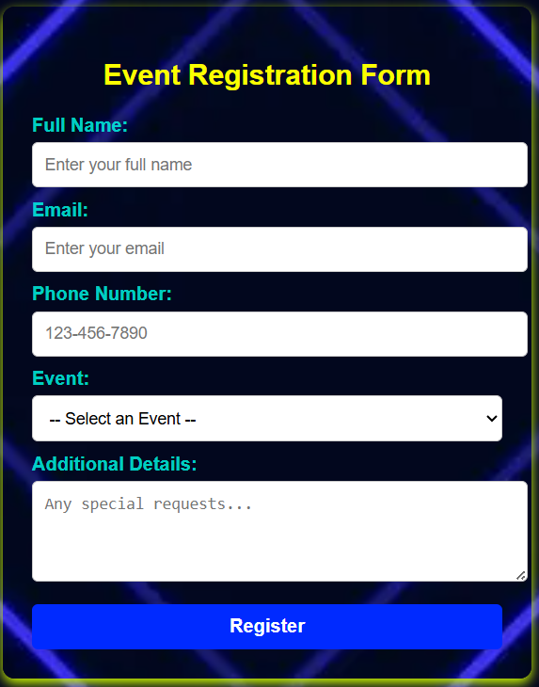

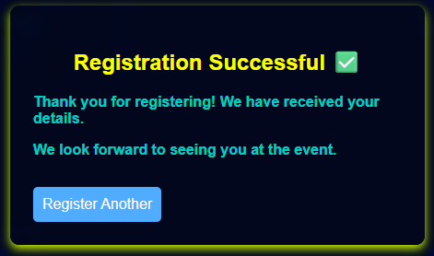

**13. Conclusion**

This project successfully demonstrates how HTML and CSS can be used to design a functional and visually appealing event registration website. It offers a clean layout, easy navigation, and a user-friendly form for participants. By hosting it via an IP address, it becomes accessible to others on the network. The development process enhanced understanding of web design principles, styling techniques, and deployment methods. Overall, it serves as a simple yet effective example of a basic web application.

**14. References**

* L&T LMS – Learn and Explore Platform: <https://learn.lntedutech.com/Landing/MyCourse>
* W3Schools – HTML & CSS Tutorials: [https://www.w3schools.com](https://www.w3schools.com/)
* MDN Web Docs – Web Development Documentation: [https://developer.mozilla.org](https://developer.mozilla.org/)
* FreeCodeCamp – Front-End Development Resources: [https://www.freecodecamp.org](https://www.freecodecamp.org/)
* CSS-Tricks – CSS Tips and Techniques: [https://css-tricks.com](https://css-tricks.com/)